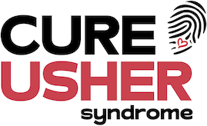

Sponsorship Form

Name of Participant:  Contact Details: | Event:  Date:

Gift Aid: Please consider Gift Aid to make your donation worth 25% more.
(Please note, you must be a taxpayer paying more tax than the amount we reclaim in order for us to claim Gift Aid from your sponsorship)

Name | Address  (Please provide your postcode  which is essential for Gift Aid) | Postcode | Amount | Gift Aid  (Please  Tick) ✓ | Tick if  Paid ✓

On behalf of CUREUsher, thank you so much for your help and contributions.
Funds raised will go towards research into Usher syndrome which is the leading cause of genetically inherited combined hearing and sight loss.

